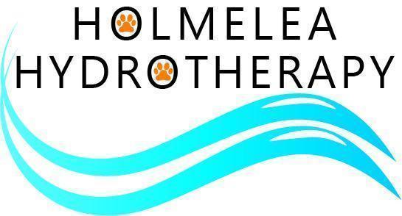

TERMS & CONDITIONS

The following terms and conditions apply to all clients using the services of Holmelea Hydrotherapy. By booking an appointment or attending a session, you agree to these terms and conditions.

- Hydrotherapy treatment can only commence following receipt of a completed veterinary referral/consent form.
- The owner authorises Holmelea Hydrotherapy to communicate with their veterinary surgeon regarding their dog's treatment and progress.
- All information provided regarding the dog's health must be accurate and complete, and the owner agrees to inform the centre immediately of any changes to the dog's medical condition, medication or veterinary advice.
- Holmelea Hydrotherapy reserves the right to refuse or postpone treatment if it considers the dog unfit for hydrotherapy.
- All dogs must be free from contagious or infectious diseases.
- Dogs must not have open wounds, untreated skin conditions, ear infections or any condition that could compromise safety or water quality.
- Bitches in season must not attend appointments until their season has fully finished.
- Owners may be asked to provide evidence that vaccinations are up to date or to complete any health declaration required by Holmelea Hydrotherapy.

CANCELLATION POLICY

- A minimum of 24 hours’ notice is required to cancel or rearrange an appointment.
- Appointments cancelled with less than 24 hours’ notice may be charged in full.
- Failure to attend an appointment without notice (“No Show”) will result in the full appointment fee being payable.
- Holmelea Hydrotherapy reserves the right to waive cancellation charges in exceptional circumstances.

PAYMENT

- Payment is due at the time of treatment unless agreed otherwise.
- Block bookings must be paid in advance.
- Unused sessions are non-refundable but may be transferred to another appointment at the Centre's discretion.

OWNER RESPONSIBILTIES

Owners agree to:

- Keep their dog on a lead at all times unless instructed otherwise.
- Ensure their dog has been toileted before entering the pool enclosure.
- Remove all dog waste and use the bins provided.
- Not feed their dog within 2 hours of their hydrotherapy appointment.
- Follow all instructions given by Centre staff.
- Wear suitable footwear as floors may be wet and slippery.

Holmelea Hydrotherapy reserves the right to refuse treatment if a dog displays behaviour that presents a risk to staff, other dogs or owners.
Owners remain responsible for their dog's behaviour at all times while on the premises.

POOL HYGIENE

If a dog fouls or vomits in the hydrotherapy pool, treatment will stop immediately. The owner may be liable for a cleaning charge of £25 if the pool requires closure and disinfection before further use.

SAFETY

Whilst every reasonable care is taken to ensure the safety and wellbeing of every dog, hydrotherapy involves inherent risks. Holmelea Hydrotherapy will take all reasonable precautions; however treatment is undertaken at the owner's risk. Nothing within these Terms excludes or limits liability for death or personal injury caused by negligence, fraud or any other liability that cannot legally be excluded under UK law.

Holmelea Hydrotherapy accepts no responsibility for loss or damage to personal belongings brought onto the premises unless caused by the Centre's negligence.

Photographs or videos may be taken for clinical records. Marketing images will only be used with the owner's prior consent.

DATA PROTECTION

Personal information will be processed in accordance with applicable UK data protection legislation. Client information will only be shared with veterinary professionals involved in the dog's care or where required by law.

INSURANCE CLAIMS

Where treatment forms part of an insurance claim:

- The owner remains responsible for payment of all fees.
- Insurance reimbursement is solely between the owner and their insurer.

RIGHT TO REFUSE TREATMENT

Holmelea Hydrotherapy reserves the right to refuse or discontinue treatment where:

- Treatment is not in the dog's best interests.
- Veterinary advice changes.
- The owner fails to comply with these Terms.
- Staff safety or animal welfare may be compromised.

These Terms and Conditions may be updated from time to time. The latest version will be available at the Centre and on our website.

