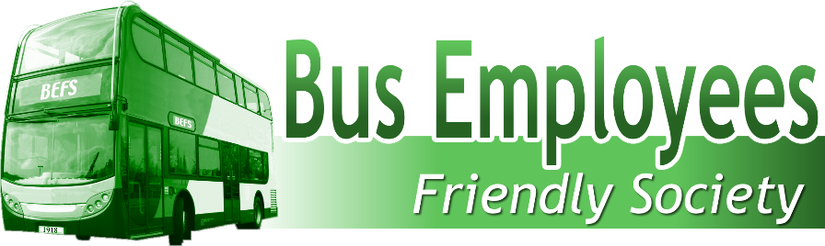

Suite 2 Alma House, Alma Road, Reigate Surrey RH2 0AX
Telephone: 01737 226060 Email: befs@supanet.com
Website: www.busemployees.co.uk

Form of Proxy

To be held online via Zoom
on Tuesday 07 September 2021 at 14.30pm

Notes
- Every member has the right to appoint a proxyholder to vote on their behalf.
- You may appoint the Chairman of the meeting or any other person in attendance.

Appointment of Proxyholder

I instruct the Chairman of the meeting or the following person:

Please leave this box blank if you wish to appoint the Chairman of the meeting
to vote on my behalf at the AGM of the Bus Employees Friendly Society to be held on 7th September 2021 at 12 noon, and any adjournment thereof.

Your name Member No.

Your address

Your signature Date of signing

Please indicate your voting instructions by inserting an X in the appropriate boxes below.

If you have appointed the Chairman of the Society to vote on your behalf, he can vote as he chooses, and you do not have to complete this form.

A vote withheld is not a vote in law and will not be counted in the calculation of the proportion of the votes for and against any resolution.

Resolutions | For | Against | Abstain/ withheld
1. To confirm the minutes of the Annual General Meeting held on Thursday 31 July 2020
2. To adopt the Financial Statements for the year ended 31 December 2020
3. To re-elect P Burchell to the Board of Management.
4 To re-elect R Hodgetts to the Board of Management.
5. To re-elect C Sullivan to the Board of Management.
6 To re-elect A Powell to the Board of Management.
7. To re-elect Messrs Cocksedge and Quinn to the Board of Management.
8. To consider and adopt amendments to the Rules governing the Society

If you wish to attend, please apply by email before close of business on 3rd September and the Zoom link will be emailed

