360 Mini Diggers 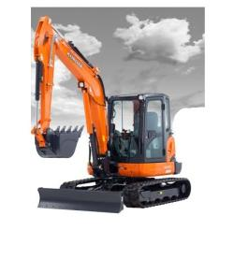
1 Day 2 Day 3 Day 5 Day/Week
Kubota KX 008 0.75 Ton Micro Digger £55.00 £110.00 £165.00 £230.00
Kubota KX 015-4 1.5 Ton Mini Digger £55.00 £110.00 £165.00 £230.00
Kubota KX 016-4 1.6 Ton Mini Digger £60.00 £120.00 £180.00 £240.00
Kubota KX 61-3 2.5 Ton Mini Digger £65.00 £130.00 £195.00 £260.00
Kubota KX 91-3 3.0 Ton Mini Digger £75.00 £150.00 £225.00 £290.00
Kubota KX 101-4 4.0 Ton Mini Digger £80.00 £160.00 £240.00 £300.00
Kubota KX 161-3 5.0 Ton Mini Digger £85.00 £170.00 £255.00 £350.00
Kubota KX 057-3 6.0 Ton Mini Digger £95.00 £190.00 £275.00 £370.00
Kubota KX 080-3 8.0 Ton Mini Digger £105.00 £210.00 £315.00 £420.00
Hydraulic Pecker for 1.5/1.6 Ton Mini Digger £30.00 per Day
Hydraulic Pecker for 3/4 Ton Mini Digger £50.00 per Day
Hydraulic Pecker for 5/6 Ton Mini Digger £60.00 per Day

Dumpers 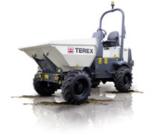

1 Day 2 Day 3 Day 5 Day/Week
¼ Ton Track Barrow £30.00 £50.00 £75.00 £90.00
1 Ton High Tip 4 Wheel Drive Dumper £45.00 £70.00 £95.00 £120.00
1.5 Ton High Tip Swivel Dumper £45.00 £70.00 £90.00 £120.00
2.0 Ton High Tip Swivel Dumper £50.00 £70.00 £95.00 £120.00
3 Ton Alldrive Swivel Dumper £55.00 £70.00 £90.00 £110.00
6 Ton Swivel Dumper £75.00 £95.00 £110.00 £140.00
9 Ton Alldrive Dumper £90.00 £150.00 £180.00 £210.00

Rollers 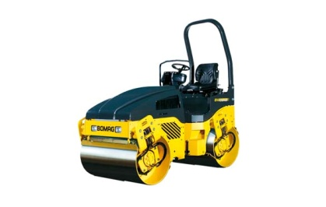

1 Day 2 Day 3 Day 5 Day/Week

Bomag BW71E Single Drum Pedestrian Roller £30.00 £45.00 £50.00 £65.00
Bomag 80 Sit on Roller £50.00 £80.00 £95.00 £110.00
Bomag 120 Sit on Roller £60.00 £80.00 £100.00 £130.00
Bomag 135 Sit on Roller £70.00 £90.00 £115.00 £150.00

Skidsteer Loaders 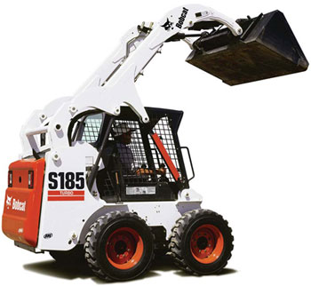

1 Day 2 Day 3 Day 5 Day/Week

Bobcat S130 Loader £60.00 £120.00 £180.00 £260.00
Bobcat S185 H/F Loader £85.00 £170.00 £255.00 £325.00
18” Quick Cut Patch Planer £50.00 £100.00 £150.00 £250.00
H/D Sweeper Collector Brush £25.00 £50.00 £75.00 £125.00
Pallet Forks £12.50 £25.00 £37.50 £50.00
Other Attachments Please ring for details
Road Planeing Picks £3.50 each

Tele Handlers 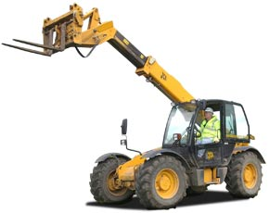

1 Day 2 Day 3 Day 5 Day/Week

9.0 Meter Tele Handler £80.00 £160.00 £240.00 £300.00
12.5 Meter Tele Handler £95.00 £190.00 £275.00 £370.00

Compressors & Tools 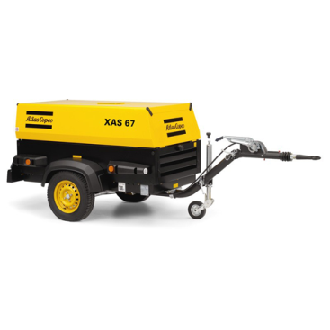
1 Day 2 Day 3 Day 5 Day/Week
85 CFM Compressor £35.00 £45.00 £55.00 £70.00
85 CFM Compressor + 1 Air Tool £50.00 £70.00 £80.00 £90.00
129 CFM Compressor £50.00 £70.00 £80.00 £90.00
129 CFM Compressor + 2 Air Tools £70.00 £85.00 £95.00 £110.00
170 CFM Compressor £65.00 £75.00 £85.00 £120.00
250 CFM Compressor £80.00 £110.00 £140.00 £160.00
CP9 Drills £15.00 £20.00 £25.00 £30.00
Demo Pick £15.00 £20.00 £25.00 £30.00
Road Breakers £15.00 £20.00 £25.00 £30.00
Air Lance £10.50 Minimum Week Hire
Air Hose £5.00 Minimum Week Hire
Small Shot Blasting Pot £30.00 £50.00 £70.00 £90.00

Compactors / Trench Rammers 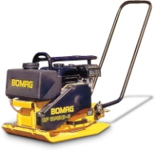

1 Day 2 Day 3 Day 5 Day/Week
300mm Plate Compactor £17.50 £24.00 £29.00 £35.00
400mm Plate Compactor £17.50 £24.00 £29.00 £35.00
450mm Plate Compactor £17.50 £24.00 £29.00 £35.00
Trench Rammer 2 Stroke £22.00 £26.00 £31.00 £40.00
Trench Rammer 4 Stroke £25.00 £30.00 £35.00 £40.00
Forward – Reverse Compactor £40.00 £50.00 £60.00 £70.00

Small / Medium Breakers 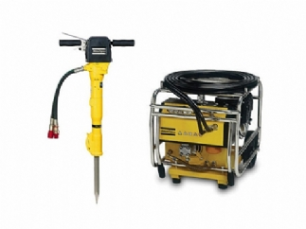

1 Day 2 Day 3 Day 5 Day/Week
Bosch GSH 11 Small Electric Breaker £25.00 £35.00 £40.00 £48.00
Kango 950 H/D Electric Breaker £25.00 £35.00 £40.00 £48.00
Bosch Brute Electric Jackhammer £26.00 £36.00 £41.00 £49.00
Wacker BH24 2 Stroke Jackhammer £35.00 £45.00 £55.00 £65.00
Hydraulic Breaker Pack and Gun £40.00 £45.00 £55.00 £65.00
Steels, Points, Chisels & T/C £2.00 Per Steel

Concrete Mixers 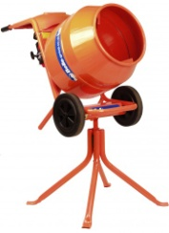

1 Day 2 Day 3 Day 5 Day/Week
½ Bag Cement Mixer (petrol) £15.00 £20.00 £22.00 £25.00
½ Bag Cement Mixer (110v) £15.00 £20.00 £22.00 £25.00
5.3 1/2 Site Cement Mixer £30.00 Minimum Week Hire

Water Pumps 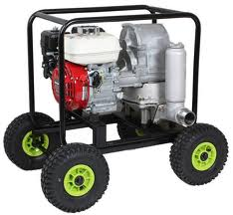

1 Day 2 Day 3 Day 5 Day/Week
2” Submersible Pump (110v) £20.00 £25.00 £30.00 £35.00
2” Diaphragm Petrol Pump c/w 20x20 Hose £30.00 £35.00 £45.00 £50.00
3” Diesel Pump c/w 20x20 Hose £40.00 £50.00 £60.00 £80.00

Water Bowser 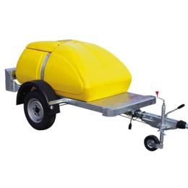

1 Day 2 Day 3 Day 5 Day/Week
250 Gallon Water Bowser £30.00 Minimum Week Hire
500 Gallon Water Bowser £40.00 Minimum Week Hire
Refill Charge Please phone for price

Generators 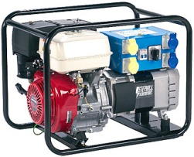

1 Day 2 Day 3 Day 5 Day/Week
1.5 KVA Generator (Petrol) £15.00 £20.00 £25.00 £30.00
3.4 KVA Generator (Petrol) £30.00 £35.00 £45.00 £55.00
5 KVA Generator £40.00 £55.00 £65.00 £85.00

Barrow Hoists 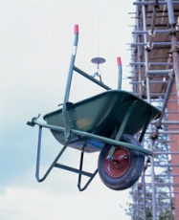

1 Day 2 Day 3 Day 5 Day/Week
150kg Hoist, 2x Barrows, Generator & Cable £90.00

Sawing & Cutting 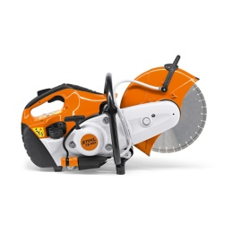

1 Day 2 Day 3 Day 5 Day/Week
Stihl Cut off Saw £20.00 £25.00 £30.00 £40.00
Floor Saw 18” Petrol £50.00 £70.00 £80.00 £120.00
Diamond Blades Prices from £45.00
Drills 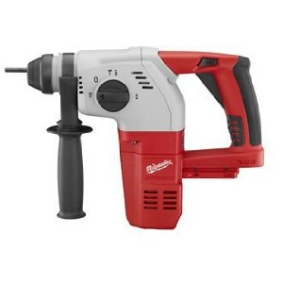

1 Day 2 Day 3 Day 5 Day/Week
Kango SDS Plus Rotary Hammer Drill £10.00 £13.00 £16.00 £22.00
Kango SDS Max Rotary Hammer Drill £15.50 £19.50 £23.50 £30.00
18.0 Volt Cordless Drill £10.00 £16.00 £21.00 £25.00
24.0 Volt Cordless Drill £13.00 £21.00 £28.00 £35.00

Concrete 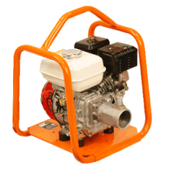
1 Day 2 Day 3 Day 5 Day/Week
Easy Screed Board 3.2 meters £40.00 £55.00 £65.00 £80.00
Power Tamp £40.00 £55.00 £65.00 £80.00
Poker & Unit 300-600mm £30.00 £40.00 £50.00 £60.00
Air Pokers £30.00 £40.00 £50.00 £60.00
Power Float £35.00 £50.00 £65.00 £80.00
Bull Float & Extension £18.00 £25.00 £32.00 £36.00

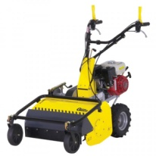
Ground Care

1 Day 2 Day 3 Day 5 Day/Week
Stihl FS450 Strimmer £30.00 £40.00 £50.00 £65.00
Stihl HS81R Hedge Trimmer £30.00 £40.00 £50.00 £65.00
Stihl HL95 Pole Hedge Trimmer £30.00 £40.00 £50.00 £65.00
BCS Flail Mower £55.00 £65.00 £75.00 £90.00
Lawnflite MTD Rotavator £50.00 £60.00 £70.00 £85.00
Stihl BT121 Post Hole Borer £30.00 £40.00 £50.00 £60.00

Miscellaneous 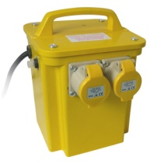

1 Day 2 Day 3 Day 5 Day/Week
3 KVA Transformers £4.00 £7.00 £9.00 £10.00
5 KVA Transformers £7.00 £10.00 £12.00 £15.00
110V Extension Leads £5.00 Minimum Week Hire 110V Flood Lamps £10.00 Minimum Week Hire
110V 4 Way Box £10.00 Minimum Week Hire
Block Cutter £30.00 Minimum Week Hire
Angle Grinders £15.00 £18.00 £20.00 £25.00
110V Saws £15.00 £18.00 £20.00 £25.00

