PENINSULA

Working on

1100mm width x 2200mm length to sit between both windows

DRESSER CAB WILL SIT ON WALL NOW

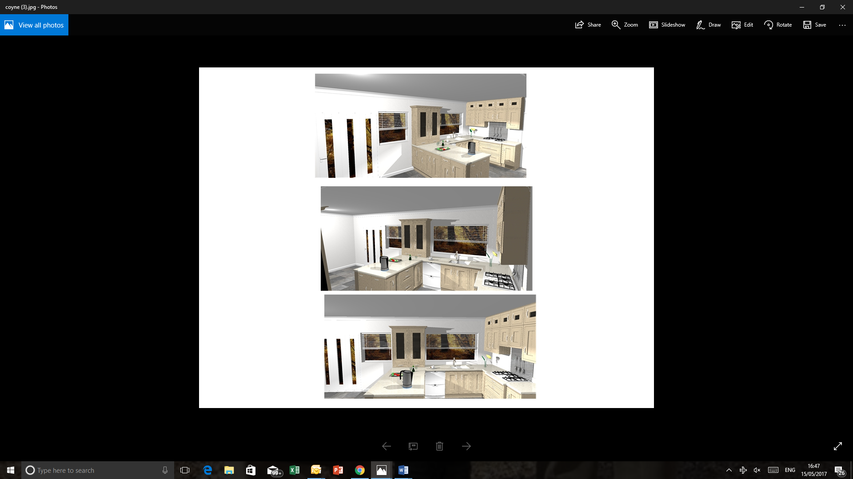

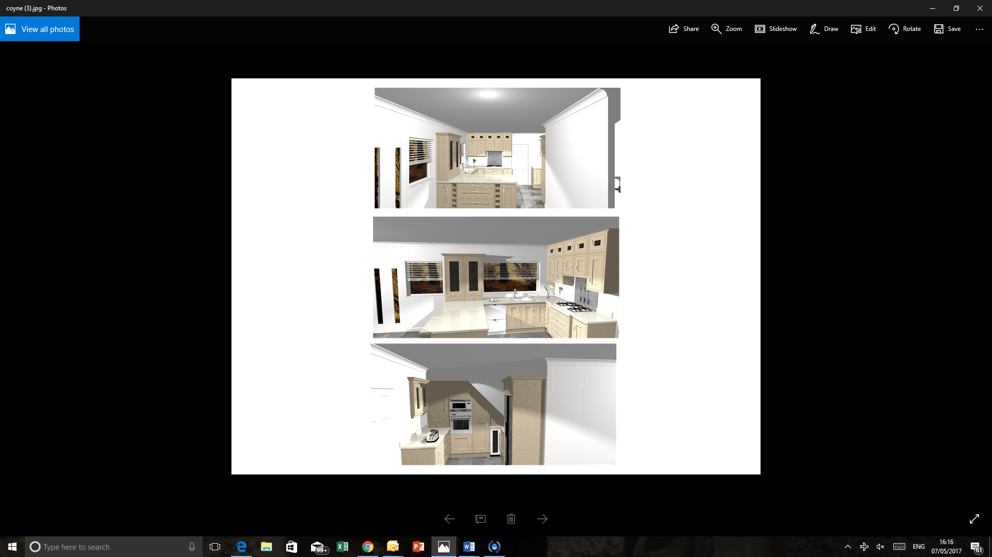 normal wall cabinet not full length

300MM

300/400MM(NOT SURE) 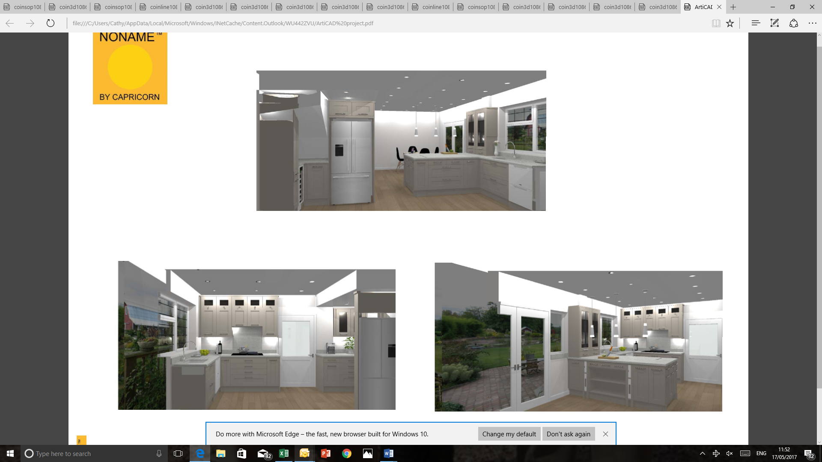

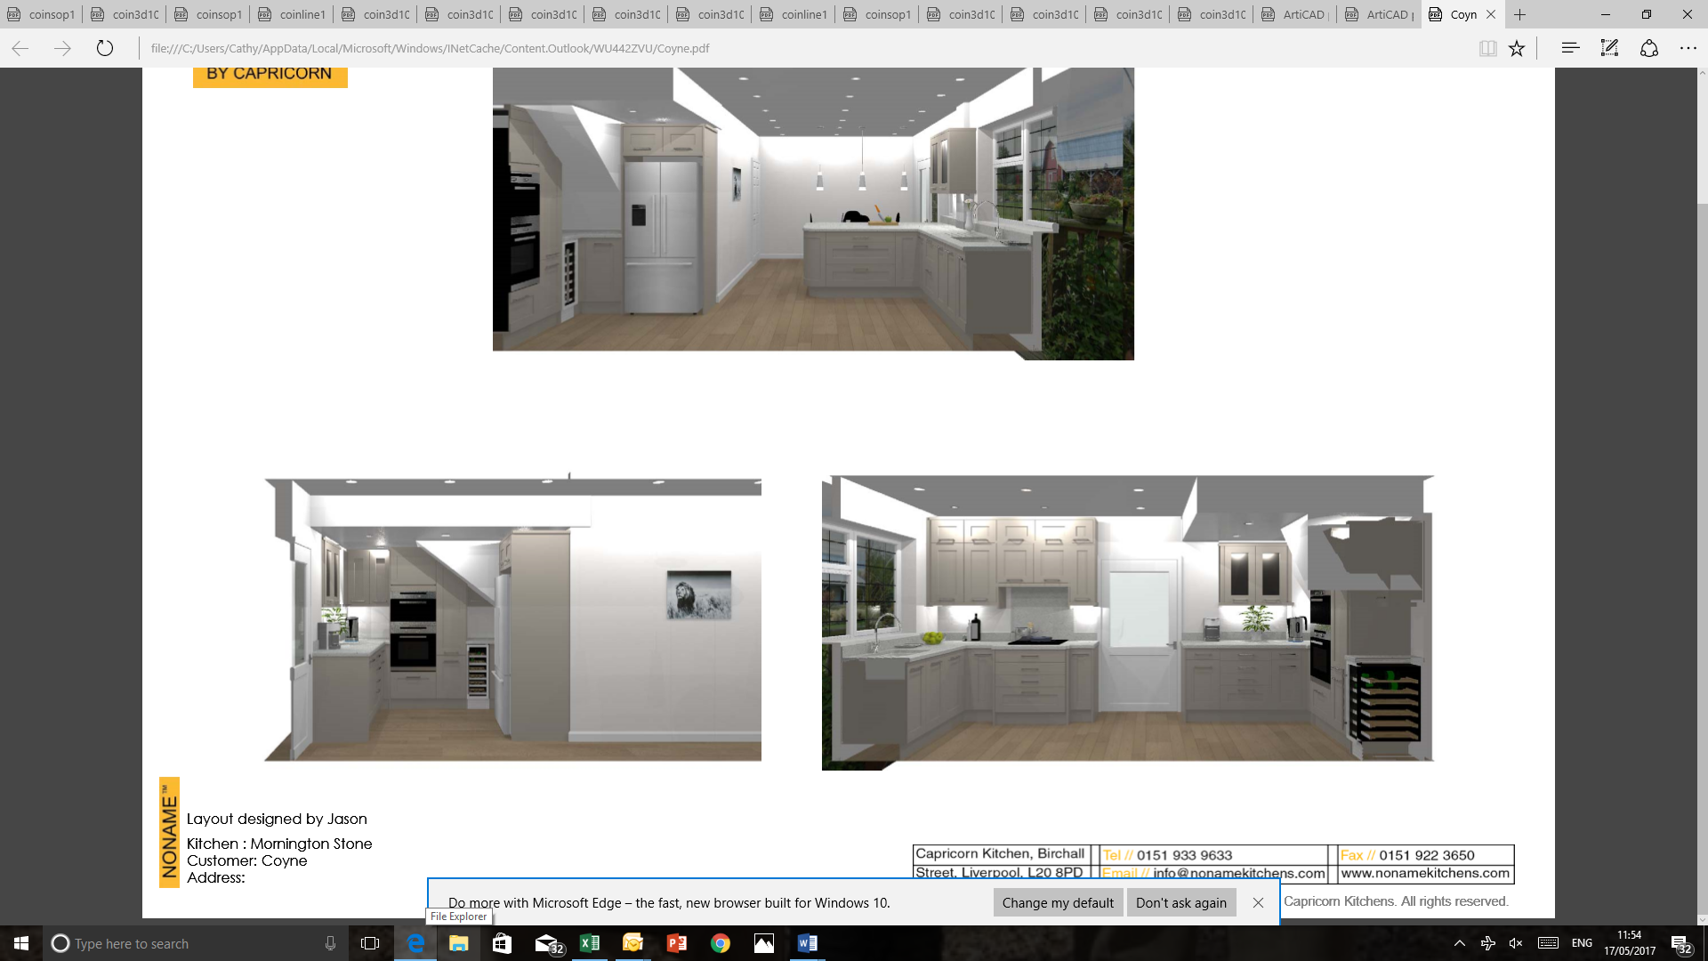

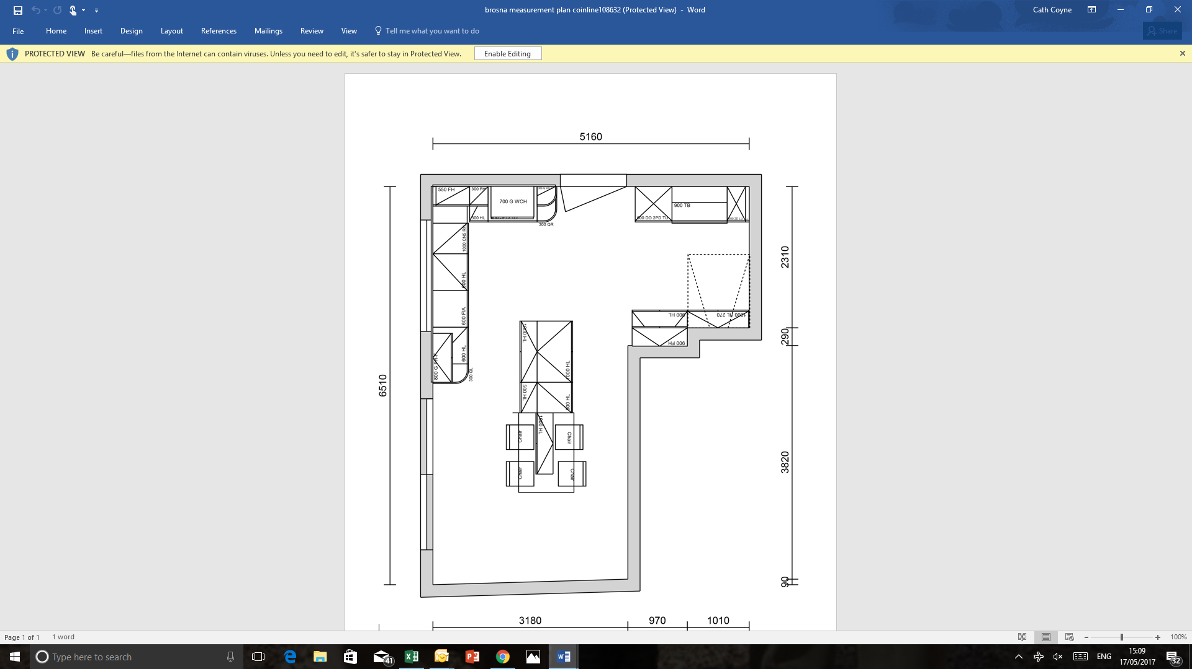

PENINSULA 110CM X 220CM

STRAIGHT WORKTOP NOW

WORKTOP IN CORNER